**CST8257 Web Application Development**

Lab 3

# Objective

1. Form Validation – Self posting
2. Use Regular Expression to validate user inputs

# Due Date

See Brightspace posting for the due date. To earn 5 points, you are required:

1. Complete the lab as required.
2. Submit your lab work to the Blackboard before the due date.
3. Demo me your lab work

# Requirements

1. Combine html page **DepositCalculator.html** and PHP page **DepositCalculator.php** you created in lab 2 into one page page **DepositCalculator.php**. When accessed, this php page represents the user a web form as below:

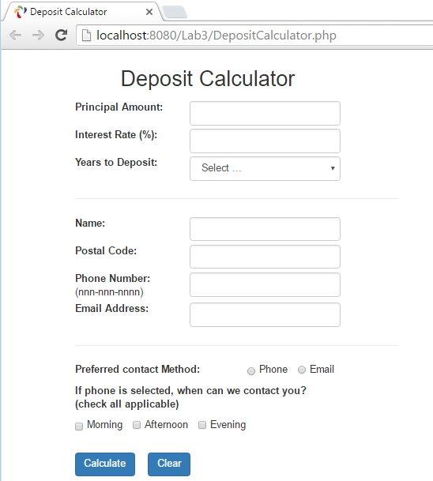

1. Once the user click the Calculate button, the web form is submitted to **DepositCalculator.php** page itself. The this page will then validate the data entered by the user according to the following rules:

* The user must enter data in all fields, no field can be blank.
* Principal Amount must be numeric and greater than zero.
* Interest Rate must be numeric and not negative.
* Number of years to deposit must be a numeric between 1 and 20.
* Postal code must be in the form of XnX nXn, where X is an upper or lower case letter and n is a digit from 0 to 9, with or without space between the first 3 characters and the last 3 characters.
* Phone number must be in the form of nnn-nnn-nnnn where n is a digit, the first n in the first and the second 3-digit groups cannot be 0 or 1.
* Email must be in the form of [aaa@xxx.yyy](mailto:aaa@xxx.yyy) where aaa and xxx is a character (including dot “.”) string of any length, yyy is a 2 to 4 characters string.

If the submitted form fails to pass the validation, the page displays the same web form again with error messages next to the invalid fields as shown below:

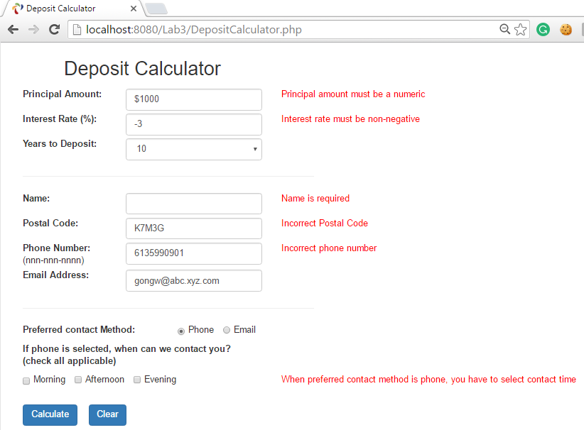

Besides presenting the error messages, the page should have the following properties:

* To improve usability, all the user’s previous entered values should be preserved so that the user does have to re-enter valid values and only easily see what’s wrong with the invalid fields and revise accordingly.
* When the Clear button is click, all the entered values should be cleared so that the web form is presented in its initial state as in 1.

1. If all fields are valid, the page will present the result of calculation as below:

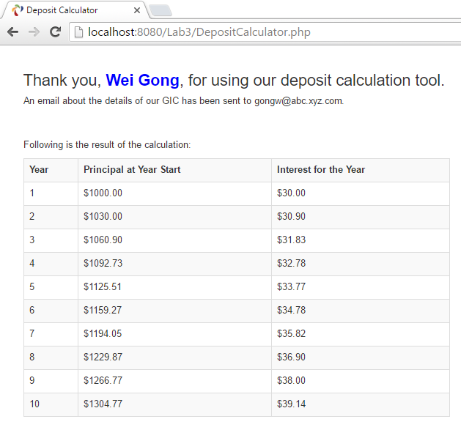

1. Besides satisfy the above requirements, your PHP page should define and use the following PHP functions to validate user inputs. If the validation fails, they return the relevent error message, otherwise, an empty string:

function ValidatePrincipal($amount) { … }

function ValidateRate($amount) { … }

function ValidateYears($years) { … }

function ValidateName($name) { … }

function ValidatePostalCode($postalCode) { … }

function ValidatePhone($phone) { … }

function ValidateEmail($email) { … }

1. Make your best efforts to style the PHP page with Bootstrap. To learn Bootstrap go to website <http://www.w3schools.com/bootstrap/>